Replace and modernize legacy VPN architectures with a cloud-native Zscaler Zero Trust solution to reduce attack surface and lateral movement.
GROUP DETAILS: 5 Members
NAME: R GOWSALYA (Team Lead)
R DEVA PRASAD
S VIKASH
T MANGALASAMY
VIGNESH S
COLLEGE NAME: SHRI NEHRU MAHA VIDHYALAYA COLLEGE OF ARTS AND SCIENCE
CONTACT: gowsalyarajasekaran@gmail.com
devaking2205@gmail.com
vv066979@gmail.com
mani8870514923@gmail.com
vv253041@gmail.com

PROJECT DETAILS

Title: Replace and modernize legacy VPN architectures with a cloud-native Zscaler Zero Trust solution to reduce attack surface and lateral movement.

Due to the increasing number of cyber threats and the changes in modern network environments, organizations need stronger and smarter security systems. In traditional networks, security was mainly based on the VPN model, which followed the castle-and-moat approach. In this model, once a user enters the network through VPN, they often receive broad access to internal resources. This can create security risks because attackers who gain access may move freely inside the network.
To solve this problem, this project focuses on replacing the traditional VPN system with a cloud-based Zero Trust security architecture using Zscaler. The Zero Trust model follows the principle “Never Trust, Always Verify.” Instead of giving users access to the entire network, users are only allowed to access the specific applications they need.
In this architecture, applications are hidden from the public internet, which reduces the chances of cyber-attacks. Users connect directly and securely to the applications through Zscaler, rather than connecting to the full network. This approach greatly reduces the attack surface and prevents lateral movement, meaning that even if a threat enters the system, it cannot easily spread across the network.
Another advantage of this system is that it provides better performance for employees working remotely or in hybrid environments. Since the security service is cloud-based, users can connect to applications quickly without routing traffic through a central data centre.
Overall, implementing Zscaler Zero Trust architecture improves the organization’s security, increases flexibility, and reduces the maintenance effort required for traditional hardware-based VPN systems. This project represents an important step toward building a modern and secure IT infrastructure capable of defending against advanced cyber threats.

INTRODUCTION

With the rapid growth of digital technologies and cloud computing, organizations are facing an increasing number of cyber security threats. Traditional security systems mainly depend on a Virtual Private Network (VPN) and perimeter-based protection, where users inside the network are trusted while outsiders are restricted. However, this approach is no longer effective in today’s environment where employees work remotely, use cloud applications, and access systems from different locations.
The traditional VPN model follows a castle-and-moat security architecture, which means once a user enters the network, they may get access to many internal resources. This creates a major security risk because attackers who gain access through VPN can move freely inside the network and compromise multiple systems.
To overcome these challenges, organizations are now adopting the Zero Trust security model. The Zero Trust approach is based on the principle “Never Trust, Always Verify.” It ensures that every user and device must be authenticated and verified before accessing any application or resource.
In this project, we implement a Zero Trust architecture using Zscaler, a cloud-based security platform. Instead of giving users access to the entire network, Zscaler connects users directly to the applications they need in a secure manner. This reduces the attack surface, prevents unauthorized access, and improves overall network security.
By replacing traditional VPN systems with Zscaler Zero Trust architecture, organizations can enhance security, support remote and hybrid work environments, and protect their applications from modern cyber threats.

ABSTRACT

This project details the strategic migration from a legacy Virtual Private Network (VPN) infrastructure to a cloud-native Zero Trust Network Access (ZTNA) solution provided by Zscaler. The primary driver for this initiative is the fundamental inadequacy of traditional VPNs in the modern threat landscape. Legacy architectures operate on a "connect first, verify later" model, granting users broad access to the corporate network and, consequently, creating a significant risk of lateral movement by malicious actors. This expansive attack surface, combined with the operational overhead of managing physical appliances and the poor user experience associated with hair-pinned traffic, renders the existing model both insecure and inefficient for today's hybrid workforce.
The proposed solution leverages the Zscaler Zero Trust Exchange, a global, cloud-native platform that shifts connectivity from a network-centric to an identity and application-centric model. By making corporate applications invisible to the internet and establishing direct, secure connections between verified users and specific applications, the new architecture eliminates the concept of network-based privileges. This approach ensures that users connect to the applications they need, not the underlying network, thereby completely neutralizing the threat of lateral movement. Furthermore, it improves performance by steering traffic directly to Zscaler’s edge nodes, optimizing the user experience regardless of their location.
The expected outcomes of this modernization project are multifaceted. We anticipate a drastic reduction in the organization's attack surface and the complete elimination of lateral movement risks. This will be coupled with a simplified, scalable security posture managed from a unified cloud console, reducing operational costs and complexity. Ultimately, this transition will not only fortify our cyber defenses against sophisticated threats but also enable a secure, high-performance, and agile work environment, future-proofing the organization's security architecture.

USE CASE SCENARIOS:
Scenario 1: Third-Party Vendor Access to Finance Application
In this scenario, an external auditor needs temporary access to the university’s finance application to perform end-of-year financial reconciliation. Instead of providing a traditional VPN account, Zscaler Private Access (ZPA) is used to grant secure and limited access.
The vendor logs in through the organization’s identity provider, and access is granted only to the finance application. The system ensures that the vendor cannot access any other internal resources. The access is also time-limited, which increases security and prevents misuse.
Output:
- User identity verified (External_Auditor_Group)
- Time-bound access policy enforced (7-day validity)
- Access restricted only to the Finance Application
- No lateral movement to other systems
Scenario 2: Research Assistant Access to High-Performance Computing Cluster
In this scenario, a graduate research assistant needs SSH access to a high-performance computing (HPC) cluster to run research data analysis scripts. Using ZPA, the student connects directly to the computing cluster without exposing the SSH port to the public internet.
Output:
- User identity verified (Research_Assistant_Group)
- Protocol-specific access granted (SSH only)
- Secure micro-tunnel established to the HPC Cluster
- Other network segments remain inaccessible
Scenario 3: Administrative Staff Access to Internal File Server
In this scenario, an administrative assistant working from a remote campus office needs access to a secure file server containing student records. ZPA verifies the user's identity and also checks the security status of the device before granting access.

Output:
- User identity verified (Admin_Staff_Group)
- Device posture verified (disk encryption enabled and system updated)
- Granular file access policies applied (read/write permissions)
- Data Loss Prevention (DLP) policies active
Scenario 4: IT Administrator Secure Access to Server Management Interfaces
In this scenario, an IT administrator needs Remote Desktop Protocol (RDP) access to manage critical servers located in the organization’s data center. With ZPA, the administrator can securely connect to the server without exposing RDP ports to the internet.
Output:
- User identity verified (IT_Admin_Group)
- Privileged access workflow triggered (approval required)
- Session recording and monitoring enabled
- Micro-tunnel created to the specific server IP and port
Scenario 5: Visiting Professor Access to Library Resources
In this scenario, a visiting professor from another institution needs temporary access to digitized library archives stored on an internal server. ZPA provides secure access only to the library application without allowing the professor to enter the university’s internal network.
Output:
- User identity verified (Visiting_Faculty_Group)
- Just-in-time access granted (8-hour session limit)
- Access restricted to the Library Application Server

STAGE 1

Title of the project: -
Replace and modernize legacy VPN architectures with a cloud-native Zscaler Zero Trust solution to reduce attack surface and lateral movement.
Overview
This project focuses on improving network security by replacing the traditional Virtual Private Network (VPN) system with a Zero Trust security solution using Zscaler. In the traditional VPN model, once users connect to the network, they often get broad access to internal resources. This creates security risks because if attackers gain access, they may move across the network and cause serious damage.
To overcome this problem, the project uses Zscaler Private Access (ZPA) based on the Zero Trust principle “Never Trust, Always Verify.” Instead of giving users full network access, ZPA connects users only to the specific applications they are allowed to use.
In this system, internal applications are hidden from the internet, which reduces the attack surface and prevents unauthorized access. When a user requests access, ZPA verifies their identity and device security before creating a secure connection to the required application.
This approach improves security by preventing lateral movement, where attackers move between systems inside a network. It also improves performance for remote users and reduces the need for managing traditional VPN hardware.
Overall, this project helps create a more secure, efficient, and modern network access system for organizations.

List of Vulnerability Table:
S.no | vulnerability | CWE/CVE no.
1 | Improper Access Control | CWE-284
2 | Improper Certificate Validation | CWE-295
3 | Design Improper Restriction of Rendered UI Layers or Frames | CWE-1021
4 | Server-Side Request Forgery (SSRF) | CWE-918
5 | OWASP Top Ten 2013,2017 Category A9 - Using Components with Known Vulnerabilities | CWE-937,1035
6 | Improper Input Validation | CWE-20
7 | Improper Neutralization of Input During Web Page Generation ('Cross-site Scripting') | CWE-79
8 | Uncontrolled Resource Consumption | CWE -400
9 | Use of a Broken or Risky Cryptographic Algorithm | CWE-327
10 | Exposure of Sensitive System Information to an Unauthorized Control Sphere | CWE-497
REPORT: -
1) Vulnerability name: Improper Access Control
CWE/CVE number: CWE-284
Owasp category: A01:2021-Broken Access Control
Description: The product does not restrict or incorrectly restricts access to a resource from an unauthorized actor.
Bussiness impact: This vulnerability is significant, as it can lead to unauthorized access to sensitive data or files, potentially causing data breaches, privacy violations, and loss of user trust. Affected sites may also require configuration changes after applying a security release.
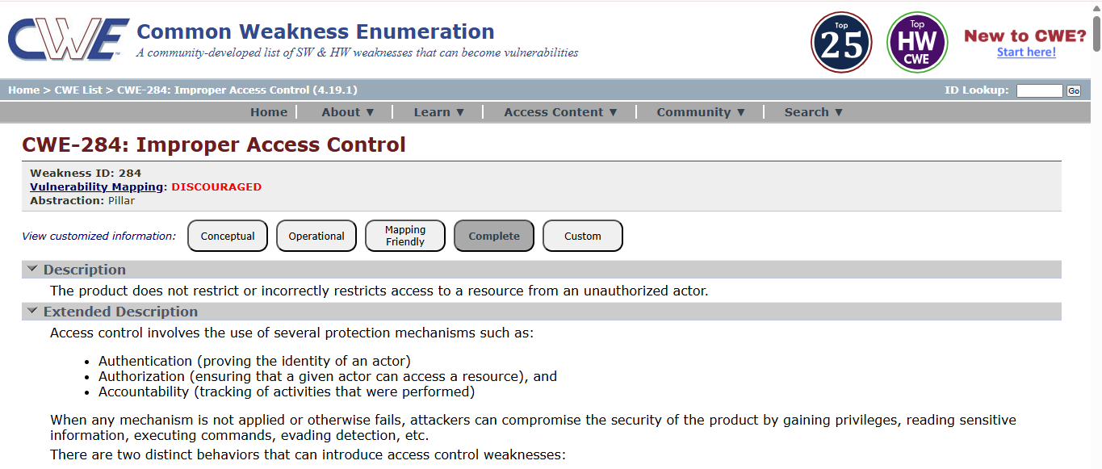
2) Vulnerability Name: Improper Certificate Validation
CWE/CVE number: CWE-295
OWASP Category: A07:2021 – Identification and Authentication Failures
Description: If a certificate is invalid or malicious, an attacker may impersonate a trusted entity by interfering with the communication between the client and host. This can cause the system to connect to a malicious host or accept fake data that appears to come from a trusted source.
Business Impact: Improper certificate validation can cause several security threats such as Man-in-the-Middle attacks, where attackers intercept and modify communication between two parties. It can also lead to data breaches, allowing unauthorized access to sensitive information, and malware distribution, where attackers use fake certificates to spread malicious software.
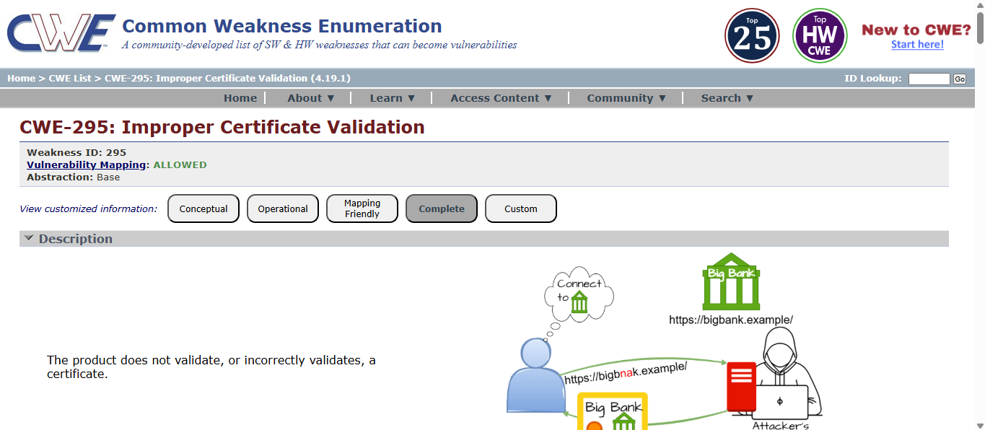
3) Vulnerability Name: Improper Restriction of Rendered UI Layers or Frames
CWE/CVE number: CWE-1021
OWASP Category: A04:2021-Insecure Design
Description: A web application is expected to place restrictions on whether it is allowed to be rendered within frames, iframes, objects, embed or applet elements. Without the restrictions, users can be tricked into interacting with the application when they were not intending to.
Business Impact: This enables path to the attackers to manipulate or gain unauthorized access to user interface elements, potentially leading to deceptive or malicious user interactions. This can result in data leakage, fraud, user distrust, and reputational damage, undermining the integrity and trustworthiness of the application and causing financial losses.
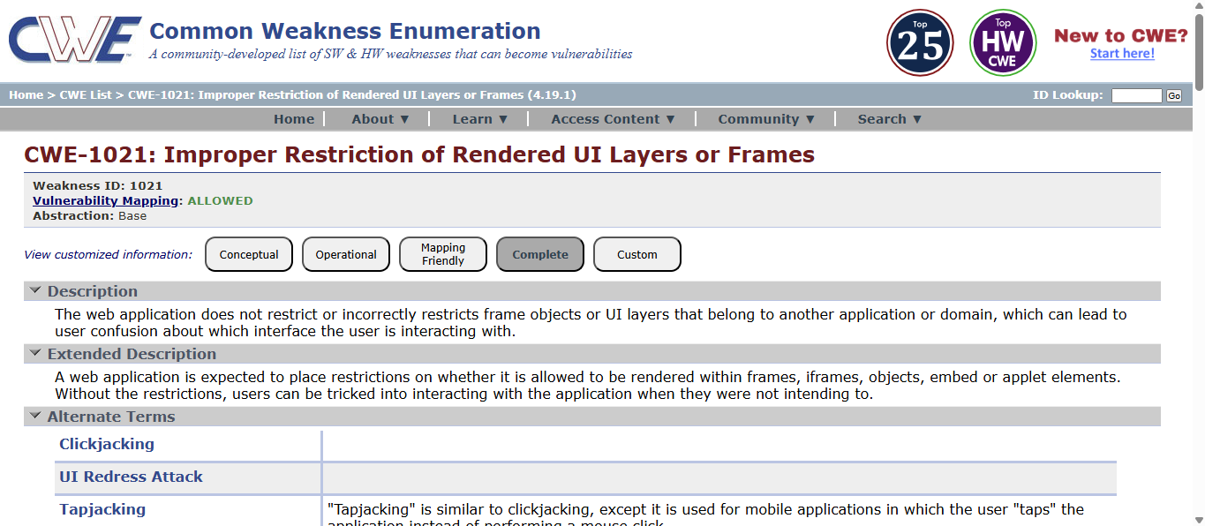

4) Vulnerability Name: Server-Side Request Forgery (SSRF)
CWE/CVE number: CWE-918
OWASP Category: A10:2021 – Server-Side Request Forgery
Description: The web server receives a URL or similar request from an upstream component and retrieves the contents of this URL, but it does not sufficiently ensure that the request is being sent to the expected destination.
Business Impact: The header missing impact Data Exposure (Attackers might force the server to render sensitive data as HTML, leading to data exposure), Security Risks (Content type manipulation can increase security risks, potentially leading to breaches, data leaks, and unauthorized access), Brand and Reputation Damage (Successful attacks that exploit SSRF vulnerabilities can harm the organization's reputation and trustworthiness)
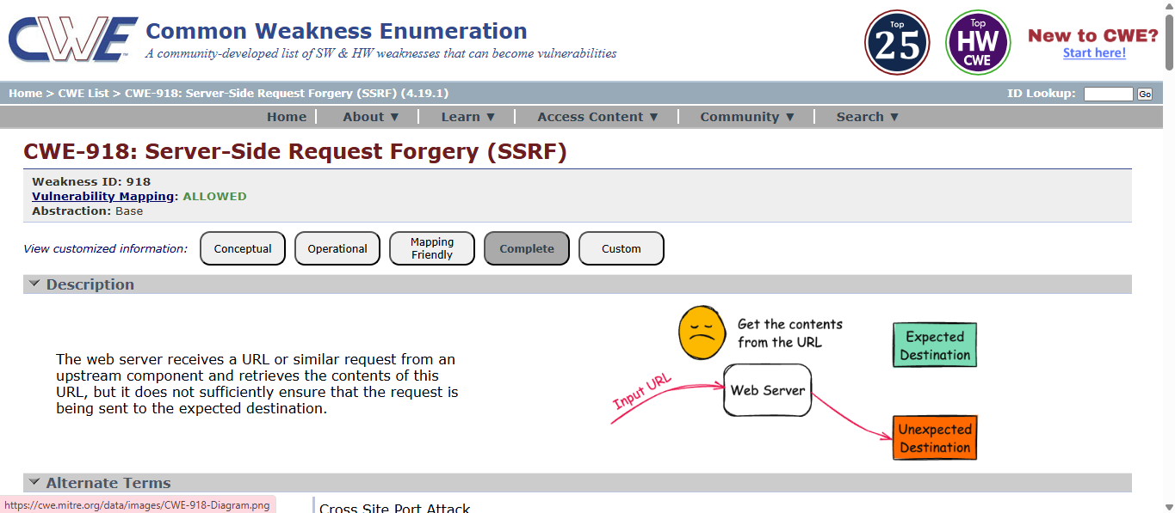
5) Vulnerability Name: OWASP Top Ten 2013,2017 Category A9 - Using Components with Known Vulnerabilities
CWE/CVE number: CWE-937,1035
OWASP Category: A06:2021-Vulnerable and Outdated Components
Description: Vulnerable and outdated components refer to using software libraries, modules, or dependencies within a web application that have known security issues or are not updated to the latest secure versions. This can include plugins, frameworks, or APIs that are no longer maintained or have publicly documented vulnerabilities.
Business Impact: The presence of vulnerable and outdated components in a web application poses significant security risks. Attackers can exploit these weaknesses to gain unauthorized access, inject malicious code, steal sensitive data, or disrupt the system's operation. The potential business impacts include compromised user data, damaged reputation, legal consequences, and financial losses due to breach recovery and remediation efforts.
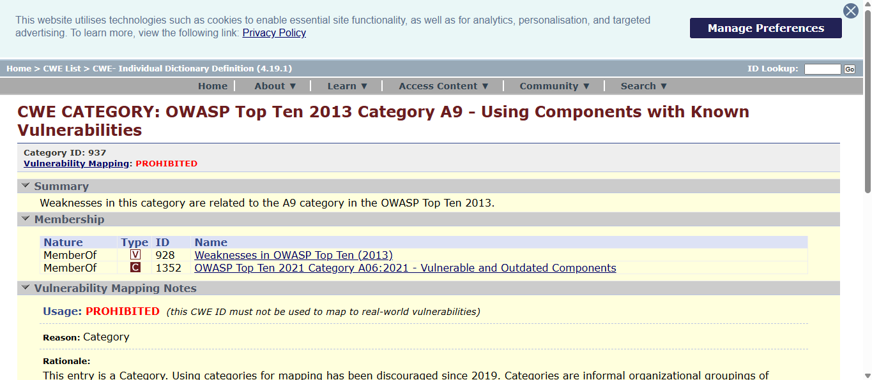
6) Vulnerability Name: Improper Input Validation
CWE/CVE number: CWE-20
OWASP Category: A03:2021 – Injection
Description: The product receives input or data, but it does not validate or incorrectly validates that the input has the properties that are required to process the data safely and correctly.
Business Impact: The impact of a successful SQL injection attack can be devastating for businesses. It can result in unauthorized access to sensitive information, data theft, financial losses, damage to reputation, and legal consequences. Depending on the nature of the application and data involved, SQL injection can lead to compliance violations, customer trust erosion, and operational disruption.
6) Vulnerability Name: Improper Neutralization of Input During Web Page Generation
CWE/CVE number: CWE-79
OWASP Category: A07-2017: Cross-site Scripting (XSS)
Description: The product does not neutralize or incorrectly neutralizes user-controllable input before it is placed in output that is used as a web page that is served to other users.
Business Impact: If exploited, this vulnerability allows attackers to inject malicious scripts into web pages, which can be viewed by other users. The potential business impacts include data theft, unauthorized access, compromised user accounts, damaged reputation, and financial losses. Attackers can use XSS to steal sensitive information, such as user credentials, personal data, or financial details, leading to regulatory compliance violations and legal liabilities. Additionally, defacement or manipulation of website content can erode customer trust and result in lost revenue.
8) Vulnerability Name: Uncontrolled Resource Consumption
CWE/CVE number: CWE-400
OWASP Category: A01 Broken Access Control
Description: A Denial of Service (DoS) attack aims to make a website, server, or application unavailable to legitimate users by sending a large number of requests or exploiting system vulnerabilities. This overloads system resources such as CPU, memory, or network bandwidth, causing slow performance, service interruption, or complete shutdown. As a result, legitimate users cannot access the service.
Business Impact: If successful, a DoS attack can slow down or crash systems, preventing users from accessing services. This can affect business operations, cause financial losses, and damage the organization’s reputation. It may also lead to compliance issues and loss of customer trust.
9) Vulnerability Name: Use of a Broken or Risky Cryptographic Algorithm
CWE/CVE number: CWE-327
OWASP Category: A02:2021-Cryptographic Failures
Description: The product uses a broken or risky cryptographic algorithm or protocol.
Business Impact: TLS 1.0 is an outdated and vulnerable encryption protocol, and its use can expose sensitive data to potential security threats. This not only jeopardizes the integrity of customer information and payment details but also tarnishes the company's reputation. The business may face legal consequences, loss of customer trust, and decreased revenue as security- conscious users avoid the site due to its security vulnerabilities. Immediate action is necessary to upgrade to a more secure TLS version to safeguard data, ensure compliance, and maintain customer confidence.
10) Vulnerability Name: Exposure of Sensitive System Information to an Unauthorized Control Sphere
CWE/CVE number: CWE-497
OWASP Category: A3:2017-Sensitive Data Exposure
Description: An information disclosure vulnerability exists in the remote web server due to the disclosure of the web. config file. An unauthenticated, remote attacker can exploit this, via a simple GET request, to disclose potentially sensitive configuration information.
Business Impact: It exposes sensitive configuration details, including database connection strings and encryption keys, to potential attackers. This could lead to unauthorized access, data breaches, and system compromise. The impact includes financial losses, damage to reputation, and legal liabilities as the organization's security and customer trust are compromised.

STAGE 2
Overview :-
Nessus is a vulnerability scanner developed by Tenable, Inc. It is a remote scanner, meaning that it does not need to be installed on the target host to scan it. Nessus works by sending a variety of probes to the target host in order to identify vulnerabilities. These probes can include network traffic, operating system commands, and application requests.
Nessus uses a plugin-based architecture. Plugins are small pieces of code that are designed to identify specific vulnerabilities. There are over 1200 plugins available for Nessus, covering a wide range of vulnerabilities in operating systems, applications, and network devices.
When Nessus scans a host, it first uses a discovery plugin to identify the operating system and services running on the host. Once the host has been discovered, Nessus runs a series of plugins to test for vulnerabilities. For each vulnerability that Nessus finds, it provides a detailed report that includes the severity of the vulnerability, the steps to reproduce the vulnerability, and the steps to remediate the vulnerability.

List of vulnerability: -
s.no | Vulnerability name | Severity | plugins
1 | TLS Version 1.0 Protocol  Detection | MEDIUM | 104743
2 | TLS Version 1.1 Protocol  Deprecated | MEDIUM | 157288
3 | SSL/TLS Diffie-Hellman Modulus  <= 1024 Bits (Logjam) | LOW | 83875
4 | ICMP Timestamp Request Remote  Date Disclosure | INFO | 10114
5 | Additional DNS Hostnames | INFO | 46180
6 | Apache Tomcat Detection | INFO | 39446
7 | Common Platform Enumeration  (CPE) | INFO | 45590
8 | Device Type | INFO | 54615
9 | HSTS Missing from HTTPS Server | INFO | 84502
10 | HTTP Server Type and Version | INFO | 10107

REPORT: -
1) Vulnerability Name: - TLS Version 1.0 Protocol Detection Severity: - MEDIUM
Plugin: - 104743
Port: - 443
Description: - The remote service accepts connections encrypted using TLS 1.0. TLS 1.0 has a number of cryptographic design flaws. Modern implementations of TLS 1.0 mitigate these problems, but newer versions of TLS like 1.2 and 1.3 are designed against these flaws and should be used whenever possible.
As of March 31, 2020, Endpoints that aren’t enabled for TLS 1.2 and higher will no longer function properly with major web browsers and major vendors.
PCI DSS v3.2 requires that TLS 1.0 be disabled entirely by June 30, 2018, except for POS POI terminals (and the SSL/TLS termination points to which they connect) that can be verified as not being susceptible to any known exploits.
Solution: - Enable support for TLS 1.2 and 1.3, and disable support for TLS 1.0.
Business Impact: -Continued use of TLS 1.0's encryption, known for its inherent cryptographic flaws, exposes the organization to heightened security risks, increasing the likelihood of data breaches and cyberattacks. This vulnerability jeopardizes compliance with industry standards, specifically PCI DSS v3.2, which mandates the complete cessation of TLS 1.0 use. Non- compliance risks regulatory penalties and erodes customer trust. Moreover, endpoints that lack support for TLS 1.2 and higher will experience impaired functionality with major web browsers and vendors, potentially leading to lost business opportunities and damage to the organization's reputation. Addressing this vulnerability is imperative to mitigate these multifaceted risks and maintain a secure and trustworthy online presence.
2) Vulnerability Name: - TLS Version 1.1 Protocol Deprecated
Severity: - MEDIUM
Plugin: - 157288
Port: - 443
Description: - The remote service accepts connections encrypted using TLS 1.1. TLS 1.1 lacks support for current and recommended cipher suites. Ciphers that support encryption before MAC computation, and authenticated encryption modes such as GCM cannot be used with TLS 1.1
As of March 31, 2020, Endpoints that are not enabled for TLS 1.2 and higher will no longer function properly with major web browsers and major vendors.
Solution: - Enable support for TLS 1.2 and/or 1.3, and disable support for TLS 1.1.
Business Impact: -The continued use of TLS 1.1 with its lack of support for modern cipher suites and advanced encryption methods jeopardizes the organization's security posture, increasing vulnerability to cyber threats and potential data breaches. Additionally, endpoints not upgraded to support TLS 1.2 and higher will encounter compatibility issues with major web browsers and vendors, impacting user experience and potentially leading to missed business opportunities. Swift remediation of this vulnerability is essential to mitigate security risks and ensure seamless interactions with web browsers and vendors, preserving the organization's reputation and operational efficiency.
3) Vulnerability Name: - SSL/TLS Diffie-Hellman Modulus <= 1024 Bits (Logjam)
Severity: - LOW
Plugin: - 83875
Port: - 443
Description: - The remote host allows SSL/TLS connections with one or more Diffie-Hellman moduli less than or equal to 1024 bits. Through cryptanalysis, a third party may be able to find the shared secret in a short amount of time (depending on modulus size and attacker resources). This may allow an attacker to recover the plaintext or potentially violate the integrity of connections.
Business Impact: - Allowing SSL/TLS connections with weak Diffie-Hellman moduli raises security concerns. An attacker with sufficient resources and computing power could compromise the shared secret relatively quickly, potentially leading to the decryption of sensitive data or the violation of connection integrity. While the severity is low, the risk of data breaches and integrity compromise should not be underestimated, and it is essential to address this vulnerability to maintain data security and user trust.
4) Vulnerability Name: -ICMP Timestamp Request Remote Date Disclosure
Severity: - INFO
Plugin: - 10114
Port: - 0
Description: - The remote host answers to an ICMP timestamp request. This allows an attacker to know the date that is set on the targeted machine, which may assist an unauthenticated, remote attacker in defeating time-based authentication protocols.
Timestamps returned from machines running Windows Vista / 7 / 2008 / 2008 R2 are deliberately incorrect, but usually within 1000 seconds of the actual system time.
Solution: - Filter out the ICMP timestamp requests (13), and the outgoing ICMP timestamp replies (14).
Business Impact: -This does not pose an immediate threat to business operations or data security. This vulnerability allows external parties to request the system's date and time information remotely. While it does not present a significant risk, it could potentially be used by attackers for reconnaissance purposes. Therefore, it is advisable to address this vulnerability as part of a broader security posture to reduce the risk of unauthorized data gathering and protect against potential future threats.
5) Vulnerability Name: - Additional DNS Hostnames Severity: - INFO
Plugin: - 46180
Port: - 0
Description: - Hostnames different from the current hostname have been collected by miscellaneous plugins. Nessus has generated a list of hostnames that point to the remote host. Note that these are only the alternate hostnames for hosts discovered on a web server.
Different web servers may be hosted on name-based virtual hosts.
Business Impact: -This does not pose an immediate threat to business operations or data security. It indicates the discovery of hostnames that are associated with the remote host, particularly in cases of web servers utilizing name-based virtual hosts. While not a security risk on its own, it could be useful for understanding the server's configuration and infrastructure.
Organizations should consider this information as part of their network documentation but do not need to take immediate action to mitigate it as a security threat.
6) Vulnerability Name: - Apache Tomcat Detection Severity: - INFO
Plugin: - 39446
Port: - 80
Description: -Nessus was able to detect a remote Apache Tomcat web server.
Business Impact: -Is an informational finding that identifies the presence of a remote Apache Tomcat web server. While this information itself does not indicate a security threat or impact on business operations, it can be useful for network administrators and security professionals to be aware of the technologies in use on their network. Understanding the presence of an Apache Tomcat server can be valuable for maintaining and securing web applications, but it does not require immediate action to mitigate a security risk.
7) Vulnerability Name: - Common Platform Enumeration (CPE) Severity: - INFO
Plugin: - 45590
Port: - 0
Description: - By using information obtained from a Nessus scan, this plugin reports CPE (Common Platform Enumeration) matches for various hardware and software products found on a host.
Note that if an official CPE is not available for the product, this plugin computes the best possible CPE based on the information available from the scan.
Business Impact: - This provides insights into hardware and software products identified on a host through a Nessus scan. It reports CPE matches, which are standardized identifiers for these products. This information is valuable for asset management and inventory purposes. While it doesn't signify a security threat, it aids administrators in understanding the components within their network, contributing to effective resource management and facilitating future system maintenance.
8) Vulnerability Name: - Device Type Severity: - INFO
Plugin: - 54615
Port: - 0
Description: - Based on the remote operating system, it is possible to determine what the remote system type is (e.g.: a printer, router, general-purpose computer, etc).
Business Impact: - It allows for the identification of the remote system type, such as a printer, router, or general-purpose computer, based on the remote operating system. While this doesn't pose a direct security threat, it offers valuable insights for network administrators to better understand and classify the devices in their network. This information aids in network
management, optimization, and ensures that the right security measures are in place for each device type.
9) Vulnerability Name: - HSTS Missing from HTTPS Server Severity: - INFO
Plugin: - 84502
Port: - 443
Description: -The remote HTTPS server is not enforcing HTTP Strict Transport Security (HSTS). HSTS is an optional response header that can be configured on the server to instruct the browser to only communicate via HTTPS. The lack of HSTS allows downgrade attacks, SSL- stripping man-in-the-middle attacks, and weakens cookie-hijacking protections.
Solution: - Configure the remote web server to use HSTS.
Business Impact: -Indicates that the remote HTTPS server does not enforce HTTP Strict Transport Security (HSTS). HSTS is a crucial security feature that, when configured on the server, instructs web browsers to communicate exclusively via HTTPS, enhancing security. The absence of HSTS potentially exposes the server to downgrade attacks, SSL-stripping man-in-the- middle attacks, and weakens protections against cookie hijacking, posing risks to data confidentiality and user security. Enabling HSTS is essential to ensure a higher level of protection for data transmitted between clients and the server.
10) Vulnerability Name: - HTTP Server Type and Version Severity: - INFO
Plugin: - 10107
Port: - 443
Description: - This plugin attempts to determine the type and the version of the remote web server.
Business Impact: -This relates to the identification of the remote web server's type and version. While this issue doesn't pose an immediate security threat, it can provide valuable information to potential attackers about the server's software stack. Knowledge of the server type and version may aid attackers in exploiting known vulnerabilities specific to that software, making it important to restrict such information from being easily accessible to enhance the server's overall security posture.

STAGE-3
Title: - Replace and modernize legacy VPN architectures with a cloud-native Zscaler Zero Trust solution to reduce attack surface and lateral movement.
Legacy VPN vs Zero Trust using Zscaler
Legacy VPN Architecture
Legacy VPN architecture is a traditional security model that creates an encrypted tunnel between a remote user and the organization’s internal network using VPN hardware devices. After authentication, users are placed directly on the internal network and are trusted to access multiple resources.
This model follows the “castle-and-moat” approach, where the internal network is trusted and the external internet is considered untrusted. Once users cross the VPN gateway, they are given broad network access based on their IP address rather than their identity.
However, this architecture was designed for a time when most users worked inside offices and applications were hosted in local data centers.

Limitations of Legacy VPN
Legacy VPN systems face many challenges in modern remote and hybrid work environments.
1. Over-permissioned access
Users receive full network access after connecting, allowing attackers to move across systems if credentials are compromised.
2. Large attack surface
VPN servers must expose ports to the internet, making them targets for cyber-attacks.
3. Poor performance
Traffic is often routed through the data center before reaching cloud applications, causing delays.
4. Scalability issues
VPN hardware has limited capacity, which can cause connection failures during peak usage.
5. High operational cost
IT teams must regularly maintain, update, and manage VPN hardware.

Attack Surface and Lateral Movement
Two major security problems in legacy VPN systems are attacking surface and lateral movement.
Attack Surface:
VPN servers exposed to the internet become easy targets for attackers who scan open ports and exploit vulnerabilities.
Lateral Movement:
Once attackers gain access using stolen credentials, they can move through the internal network to find sensitive systems such as databases, file servers, or research data.

Zero Trust Architecture
Zero Trust is a modern security framework that removes the concept of trusted networks. It follows the principle “Never Trust, Always Verify.”
Every user and device must be authenticated and verified before accessing applications, regardless of their location.
Key Principles of Zero Trust
- Assume the system may already be compromised
- Always verify user identity and device security
- Provide only minimum access required
- Use micro-segmentation to isolate applications

Zscaler Zero Trust Solution
Zscaler is a cloud-based platform that provides Zero Trust security without requiring VPN hardware.
Main Components
Zscaler Private Access (ZPA)
Provides secure access to internal applications without connecting users to the network.
Zscaler Internet Access (ZIA)
Protects internet traffic by inspecting it for threats and data leaks.
Together they replace traditional VPN systems with a secure cloud solution.

How Zscaler Reduces Attack Surface
Zscaler hides internal applications from the public internet, making them invisible to attackers.
Key methods include:
- No open inbound ports required
- Applications are not visible to port scanners
- Internal applications are not exposed through public DNS
- Zscaler cloud acts as a secure broker between users and applications

How Zscaler Prevents Lateral Movement
Zscaler connects users directly to applications instead of placing them on the internal network.
Security features include:
- Application-specific encrypted connections
- No network visibility for users
- Identity-based access control
- Continuous monitoring of user activity
This ensures attackers cannot move between systems.

Zscaler Architecture Components
1. Zscaler Client Connector
Software installed on user devices to securely route traffic.
2. Zscaler App Connector
Virtual machines deployed in the data center that securely connect internal applications to the Zscaler cloud.
3. Zscaler Cloud Platform
Global security network that enforces policies and inspects traffic.
4. Zscaler Admin Portal
Centralized dashboard used by administrators to configure policies and manage access.

Integration with Existing Systems
Zscaler integrates with other security tools in the organization.
Identity Providers
Integration with Azure AD or Okta for authentication and single sign-on.
Endpoint Security Tools
Checks device health such as antivirus status and system updates.
SIEM Systems
Security logs can be sent to platforms like Splunk for monitoring.
Threat Intelligence Platforms
Integration with threat intelligence feeds helps block malicious domains and IP addresses.

Deployment Methodology
The implementation of Zscaler follows a structured process.
Phase 1 – Planning
- Identify internal applications
- Define user groups and access requirements
- Analyze network traffic
Phase 2 – Infrastructure Setup
- Deploy App Connectors
- Configure identity provider integration
- Establish secure connectivity with Zscaler cloud
Phase 3 – Policy Configuration
- Define application access rules
- Create user-based security policies
- Configure internet security policies
Phase 4 – Pilot Deployment
- Test with a small group of users
- Monitor access and system performance
- Adjust policies if needed
Phase 5 – Full Deployment
- Roll out the solution to all users
- Provide training and documentation
- Disable the legacy VPN system
Phase 6 – Continuous Monitoring
- Review security logs
- Update policies regularly
- Monitor for potential threats

Threat Intelligence in Zscaler
Threat intelligence improves security by identifying potential cyber threats.
Sources of Threat Intelligence
- Zscaler security logs
- External threat intelligence feeds
- Identity provider login data
- Endpoint security alerts
Uses
- Detect suspicious login attempts
- Identify abnormal user activity
- Block access to malicious websites

Incident Response in Zero Trust
Incident response becomes faster and more effective in a Zero Trust environment.
Steps
Detection
Security alerts identify suspicious activity.
Containment
The compromised user or device can be immediately blocked.
Eradication
Malware is removed and compromised accounts are reset.
Recovery
Access is restored once the device is secure.
Review
Security teams analyze the incident and improve policies.
Benefits of Zero Trust with Zscaler
- Faster incident containment
- No lateral movement across the network
- Detailed security logs for analysis
- Cloud-based management
- Improved compliance with security regulations
Conclusion
- In conclusion, this project helped in understanding the importance of modern cybersecurity solutions. In Stage 1, learning about web application testing highlighted the need to identify vulnerabilities and secure web applications. Stage 2 focused on analyzing Nessus reports, which helped in understanding different system vulnerabilities and how they can be detected and managed.
- In Stage 3, the project demonstrated how replacing the traditional VPN architecture with a Zscaler Zero Trust solution improves network security. By following the principle “Never Trust, Always Verify,” Zscaler ensures that users are connected only to the specific applications they are authorized to access. This approach reduces the attack surface and prevents lateral movement, making the internal network more secure.
- Looking ahead, technologies such as AI, machine learning, and automated security tools will further strengthen cybersecurity systems. Zero Trust solutions like Zscaler will continue to evolve, helping organizations protect their networks against advanced cyber threats.
- Overall, this project provided a clear understanding of modern web security, vulnerability assessment, and Zero Trust architecture, which are essential for building a secure and future-ready IT environment.

Future Scope
- The future scope of this project is very promising because cybersecurity is continuously developing with new technologies and new threats.
- In web application testing, there will be more focus on security, since web applications are becoming more complex and are often targeted by cyberattacks. In the future, Artificial Intelligence (AI) and Machine Learning (ML) can play an important role in testing by automating tasks, identifying vulnerabilities faster, and improving accuracy. Cloud-based testing is also expected to increase because it is flexible, scalable, and cost-effective. At the same time, more attention will be given to user experience testing to make applications secure as well as user-friendly.
- In the software testing process, the future will include more continuous testing, where applications are tested throughout development. Automation tools will reduce manual effort and improve efficiency. AI and ML will further help in detecting errors, predicting risks, and improving the overall quality of software systems.
- For SOC/SIEM and Zero Trust security, the future scope is even broader. The Zscaler solution can be expanded to provide stronger protection for internal workloads, branch offices, campus networks, and even IoT devices. Advanced Data Loss Prevention (DLP) features can be added to protect sensitive student and research data. AI-driven threat hunting can help security teams detect suspicious activities early and respond quickly.
- In the future, integration with SOAR platforms can automate incident response actions such as isolating compromised devices or resetting user credentials. Compliance reporting can also be automated for standards such as FERPA, GDPR, and HIPAA. In addition, User Behavior Analytics (UBA) can be used to identify insider threats and unusual access patterns.
- Overall, the future of this project lies in combining automation, AI, cloud security, and Zero Trust principles to create a smarter, faster, and more secure cybersecurity environment.
Topics explored: -
- Data Collection and Aggregation, Standardization and Normalisation, Enrichment and Analysis, Sharing and Distribution, Integration with Security Tools, Customization and Flexibility, Automation and Orchestration, Community Involvement, Incident Response Support, Threat Intelligence Feeds, Soc and Siem
Tools explored: -
- Nmap, Metasploit, Nessus, Kali Linux, OWASP ZAP, Burp Suite
THE END

